Bence, William Last Will and Testament - 25-Jan-1900

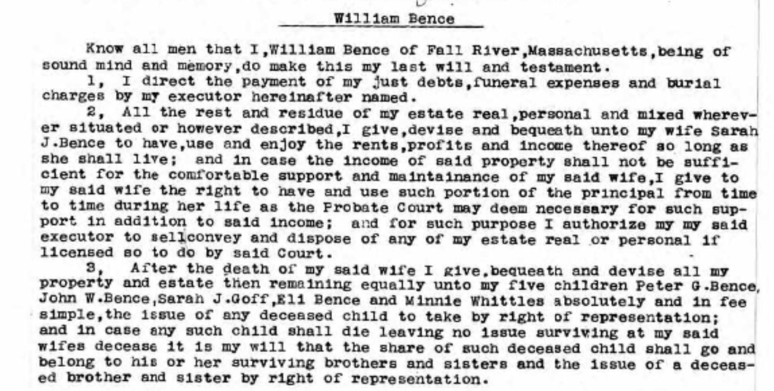
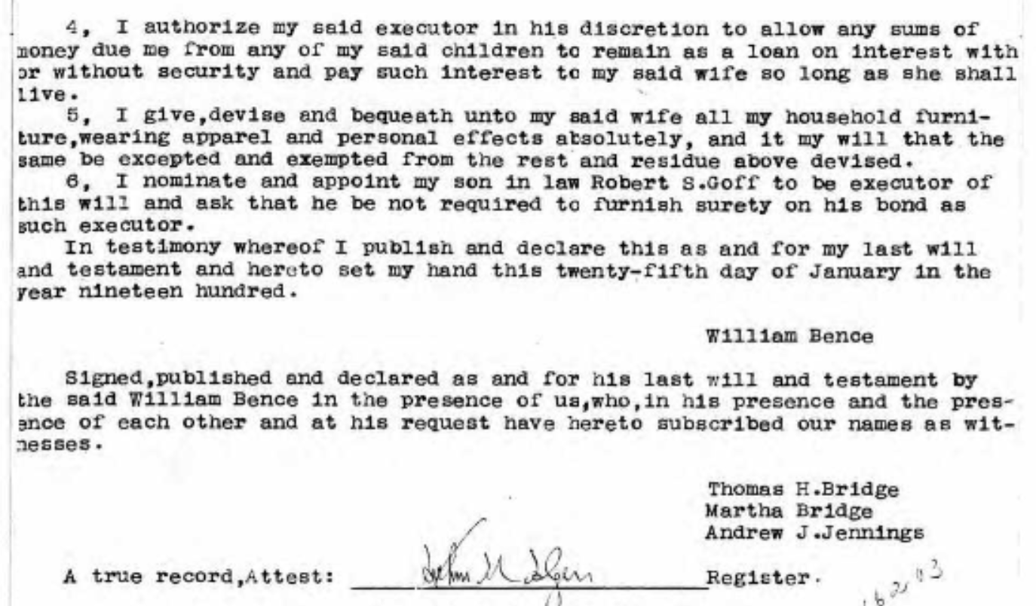

Probate Records 1687-1916; Index, 1687-1926 (Bristol County, Massachusetts);Author: Massachusetts. Probate Court (Bristol County); Probate Place: Bristol, Massachusetts
Notes : Probates, Vol 294-295, 1899-1900, image 67 of 697
Ancestry.com. Massachusetts, Wills and Probate Records, 1635-1991 [database on-line]. Provo, UT, USA: Ancestry.com Operations, Inc., 2015.
Original data: Massachusetts County, District and Probate Courts.

